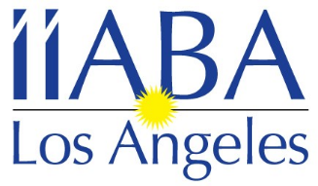 Independent Insurance Agents & Brokers Association of Los Angeles

January 2022

The Insurance Brokers and Agents of Los Angeles would like to invite you to join our local association as an Agency member. Being an Agency Member of the leading trade association of independent agents and insurance brokers in California exposes you to California’s top insurance broker and agent firms. Don’t miss your opportunity to network with IIABA-LA’s growing membership. Through IIABA-LA membership you can also become a board member. We have monthly board meetings and several events throughout the year.

Agency Member benefits for 2022 to include:

- Please provide the employees names to be included in the Los Angeles Mailing list. Please also include any other employees you would like included in our emails regarding upcoming events, etc.
- Access to the Los Angeles membership directory.
- Company name & contact information on the IIABA-LA website.
- The opportunity to network with IIABA-LA Members.
- Member pricing to all IIABA-LA events and exclusive Sponsorship opportunities.

See attached application for 2022 Los Angeles Agency Membership

For more information, please visit www.iiaba-la.com

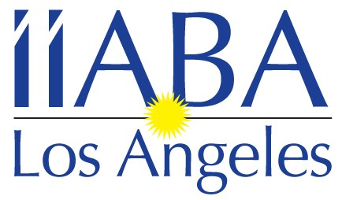

Independent Insurance Agents & Brokers Association
of Los Angeles

1171 S. Robertson Blvd. #411 Los Angeles, CA 90035
Tel: (310) 562-5254
Email: jennifer@iiaba-la.com

2022 Agency Membership Application

Company Name: ____________________________________________________

Address: ___________________________________________________________

City/State/Zip: _______________________________________________________

Contact: _____________________ Title: __________________________

Phone (area code): ________________ Number of Employees:______________

Email: ______________________________________________________________

Other Company Representatives/Officers & Titles you would like to have on our mailing lists

Name: _______________ Title: ______________ Email address:

Name: _______________ Title: ______________ Email address:

Name: ______________ Title: _______________ Email address:

Would you like this information posted on our on-line Directory? Yes_______ No______

If you have any questions, please contact Jennifer Schreter at (310) 562-5254

ANNUAL DUES will be sent to you via invoice

Make check payable and mail to: IIABA-LA
c/o Jennifer Schreter
1171 S. Robertson Blvd., #411
Los Angeles, CA 90035

www.iiaba-la.com

To pay by credit card please contact
Jennifer Schreter
2022 IIABA-LA Calendar of events
& Sponsorship Opportunities

Sponsoring these events helps us make them more affordable for our members,
and gives your company great exposure at the same time.

January 12th Board meeting
26th – Installation luncheon – Hotel Angeleno

February 9th – Board meeting

March 9th – Board meeting

April 13th – Board meeting

May 11th – Board meeting

June 8th – Board meeting

July 13th – Board meeting

August 10th – Board meeting

September 14th – Board meeting
TBD – I-Day 2022
Late month or Early October – Principal’s dinner

October 12th – 1st Budgeting Board meeting (location/time TBD )

November 9th – 2nd Budgeting Board meeting / Board Appreciation Happy
Hour @ Public School 310

December 2nd – Magic Castle Luncheon
14th – Board meeting

***These event dates and information are subject to change***

If you are interested in sponsoring any of these events please call Jennifer Schreter
at (310) 562-5254 or jennifer@iiaba-la.com

