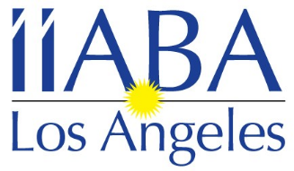 Independent Insurance Agents & Brokers Association of Los Angeles

January 2022

The Insurance Brokers and Agents of Los Angeles would like to invite you to join our local association as an Associate Member. Being an Associate Member of the leading trade association of independent agents and insurance brokers in California exposes you to California’s top insurance broker and agent firms. Don’t miss your opportunity to showcase your products and services to IIABA-LA’s growing membership. Through IIABA-LA associate membership you gain visibility and access to a growing number of independent agents and insurance brokers who recognize and appreciate your support.

Associate Member benefits for 2022 to include:

- Please provide the employees names to be included in the Los Angeles Mailing list. Please also include any other employees you would like included in our emails regarding upcoming events, etc.
- Access to the Los Angeles membership directory.
- Personalized association member webpage at www.iiaba-la.com to highlight your company and product information with direct hyperlink to your company website.
- Opportunities to advertise your products via IIABA-LA.
- The opportunity to network with IIABA-LA Members.
- Member pricing to all IIABA-LA events and exclusive Sponsorship opportunities.

See attached application for 2022 Los Angeles Associate Membership

For more information, please visit www.iiaba-la.com

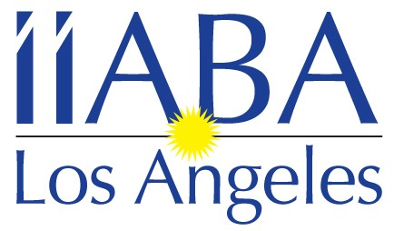

Independent Insurance Agents & Brokers Association
of Los Angeles

1171 S. Robertson Blvd. #411 Los Angeles, CA 90035
Tel: (310) 562-5254
Email: jennifer@iiaba-la.com

2022 Associate Membership Application
New ___Renewal___

Company Name _____________________________________________________________________________________

Address____________________________________________________________________________________________

City/State/Zip ______________________________________________________________________________________

Contact __________________________________________________________Title_____________________________

Phone (area code) _____/_________________

Email ____________________________________________________________________________________________

Other Company Representatives/Officers & Titles you would like to have on our mailing lists

Name _______________________ Title ___________Email address_________________________________________

Name _______________________ Title ___________Email address_________________________________________

Name _______________________ Title ___________Email address_________________________________________

Would you like this information posted on our online Directory? Yes_______ No______

If you have any questions, please contact Jennifer Schreter at (310) 562-5254

ANNUAL DUES: $350.00

Make check payable and mail to: IIABA-LA
c/o Jennifer Schreter
1171 S. Robertson Blvd., #411
Los Angeles, CA 90035

www.iiaba-la.com

To pay by credit card please contact
Jennifer Schreter
2022 IIABA-LA Calendar of events
& Sponsorship Opportunities

Sponsoring these events helps us make them more affordable for our members,
and gives your company great exposure at the same time.

January 13th – Board Meeting – via Zoom

February 9th – Board Meeting - Teleconference

March 9th – Board Meeting – via Zoom

April 13th – Board Meeting – Zoom
28th – Happy Hour at Hotel Angeleno

May 1st – 5th – IIABCal Blue Ribbon Conference in Kona, HI
11th – Board Meeting - via Zoom

June 8th – Board Meeting – via Zoom

July 13th – Board Meeting – in person luncheon,
Public School 310, Culver City

August 10th – Board Meeting – via Zoom
TBD – Summer Event + CE Class

September 14th – Board Meeting – via Zoom

October 5th – Principals Dinner
12th – 1st Budgeting Board Meeting – location time TBD

November 9th – 2nd Budgeting Board meeting / Board Appreciation Happy
Hour @ Public School 310 ??

December 2nd – Magic Castle Holiday Luncheon
14th – Board meeting – via Zoom

***These event dates and information are subject to change***

If you are interested in sponsoring any of these events please call Jennifer Schreter
at (310) 562-5254 or jennifer@iiaba-la.com

