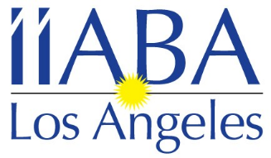 Independent Insurance Agents & Brokers Association of Los Angeles

January 2024

The Insurance Brokers and Agents of Los Angeles would like to invite you to join our local association as an Associate Member. Being an Associate Member of the leading trade association of independent agents and insurance brokers in California exposes you to California’s top insurance broker and agent firms. Don’t miss your opportunity to showcase your products and services to IIABA-LA’s growing membership. Through IIABA-LA associate membership you gain visibility and access to a growing number of independent agents and insurance brokers who recognize and appreciate your support.

Associate Member benefits for 2024 to include:

- Please provide the employees names to be included in the Los Angeles Mailing list. Please also include any other employees you would like included in our emails regarding upcoming events, etc.
- Access to the Los Angeles membership directory.
- Personalized association member webpage at www.iiaba-la.com to highlight your company and product information with direct hyperlink to your company website.
- Opportunities to advertise your products via IIABA-LA.
- The opportunity to network with IIABA-LA Members.
- Member pricing to all IIABA-LA events and exclusive Sponsorship opportunities.

See attached application for 2024 Los Angeles Associate Membership

For more information, please visit www.iiaba-la.com

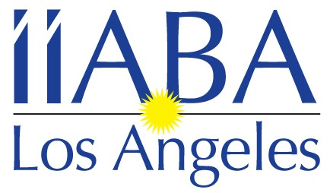

Independent Insurance Agents & Brokers Association
of Los Angeles

407 N. Pacific Coast Highway, #127Redondo Beach, CA 90277
Tel: (310) 562-5254
Email: jennifer@iiaba-la.com

2024 Associate Membership Application
New ___Renewal___

Company Name _____________________________________________________________________________________

Address____________________________________________________________________________________________

City/State/Zip ______________________________________________________________________________________

Contact __________________________________________________________Title_____________________________

Phone (area code) _____/_________________

Email ____________________________________________________________________________________________

Other Company Representatives/Officers & Titles you would like to have on our mailing lists

Name _______________________ Title ___________Email address_________________________________________

Name _______________________ Title ___________Email address_________________________________________

Name _______________________ Title ___________Email address_________________________________________

Would you like this information posted on our online Directory? Yes_______ No______

If you have any questions, please contact Jennifer Schreter at (310) 562-5254

ANNUAL DUES: $400.00

Make check payable and mail to: IIABA-LA
c/o Jennifer Schreter
407 N. Pacific Coast Highway, #127
Redondo Beach, CA 90277

www.iiaba-la.com

To pay by credit card please contact
Jennifer Schreter
2024 IIABA-LA Calendar of events
& Sponsorship Opportunities

Sponsoring these events helps us make them more affordable for our members,
and gives your company great exposure at the same time.

January 10th – Board Meeting

February 14th – Board Meeting

March 13th – Board Meeting

April 10th – Board Meeting

May 5th – 9th – IIABCal Blue Ribbon Conference in Kona, HI
8th – Board Meeting (probably will move due to conflict with BRC)

June 12th – Board Meeting

July 10th – Board Meeting

August 14th – Board Meeting
TBD – Topgolf Event

September 11th – Board Meeting

October 9th – 1st Budgeting Board Meeting –zoom
Late October – principals’ event

November 13th – 2nd Budgeting Board meeting / Board Appreciation Happy
Hour – location TBD

December 6th – Magic Castle Holiday Luncheon
11th – Board meeting

***These event dates and information are subject to change***

If you are interested in sponsoring any of these events please call Jennifer Schreter
at (310) 562-5254 or jennifer@iiaba-la.com

