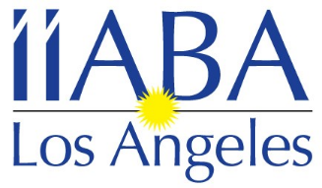

Independent Insurance Agents & Brokers Association of Los Angeles

January 2024

The Insurance Brokers and Agents of Los Angeles would like to invite you to join our local association as an Agency member. Being an Agency Member of the leading trade association of independent agents and insurance brokers in California exposes you to California’s top insurance broker and agent firms. Don’t miss your opportunity to network with IIABA-LA’s growing membership. Through IIABA-LA membership you can also become a board member. We have monthly board meetings and several events throughout the year.

- Please provide the employees names to be included in the Los Angeles Mailing list. Please also include any other employees you would like included in our emails regarding upcoming events, etc.
- Access to the Los Angeles membership directory.
- Company name & contact information on the IIABA-LA website.
- The opportunity to network with IIABA-LA Members.
- Member pricing to all IIABA-LA events and exclusive Sponsorship opportunities. If you would like to pay for a sponsorship with your membership dues; we have different levels available. Please email Jennifer (jennifer@iiaba-la.com) to learn more.

See attached application for 2024 Los Angeles Agency Membership

For more information, please visit www.iiaba-la.com

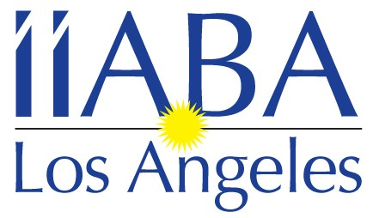

Independent Insurance Agents & Brokers Association
of Los Angeles

407 N. Pacific Coast Highway #127 Redondo Beach, CA 90278
Tel: (310) 562-5254
Email: jennifer@iiaba-la.com

2024 Agency Membership Application

Company Name: ____________________________________________________

Address: ___________________________________________________________

City/State/Zip: _______________________________________________________

Contact: _____________________ Title: __________________________

Phone (area code): ________________ Number of Employees:______________

Email: ______________________________________________________________

Other Company Representatives/Officers & Titles you would like to have on our mailing lists

Name: _______________ Title: ______________ Email address:

Name: _______________ Title: ______________ Email address:

Name: ______________ Title: _______________ Email address:

Would you like this information posted on our on-line Directory? Yes_______ No______

If you have any questions, please contact Jennifer Schreter at (310) 562-5254

ANNUAL DUES invoices will be sent to you via PayPal or email

Make check payable and mail to: IIABA-LA
c/o Jennifer Schreter
407 N. Pacific Coast Highway., #127
Redondo Beach, CA 90278

www.iiaba-la.com

To pay by credit card please contact
Jennifer Schreter

2024 IIABA-LA Calendar of events
& Sponsorship Opportunities

Sponsoring these events helps us make them more affordable for our members,
and gives your company great exposure at the same time.

January 10th – Board Meeting via Zoom
24th – Installation

February 14th – Board Meeting via Zoom

March 6th – Board Meeting – Public School 310 at 12pm
19th – I-Day (Pasadena Convention Center) 1pm-5pm

April 16th – Spring Fling Luncheon at SOL Cantina in Playa Vista
17th – Board Meeting via Zoom
10th – 12th – Big I in DC

May 5th – 9th – IIABCal Blue Ribbon Conference in Kona, HI
15th – Board Meeting via Zoom

June 12th – Board Meeting (in person location TBD)

July 10th – Board Meeting via Zoom

August 14th – Board Meeting via Zoom
TBD – Topgolf Event

September 11th – Board Meeting via Zoom

October 9th – 1st Budgeting Board Meeting –via Zoom
Late October – principals event (location TBD)

November 13th – 2nd Budgeting Board meeting / Board Appreciation Happy
Hour – location TBD

December 6th – Magic Castle Holiday Luncheon
11th – Board meeting via Zoom

***These event dates and information are subject to change***

If you are interested in sponsoring any of these events please call Jennifer Schreter
at (310) 562-5254 or jennifer@iiaba-la.com

SPONSORSHIP OPPORTUNITIES 2024

SPRING FLING LUNCHEON – APRIL 16TH
- $2000 – 4 tickets + signage + logo on eblasts/website + logo placement on name badges
- $1000 – 2 tickets + signage + logo on eblasts
- Raffle items
TOPGOLF - AUGUST
- $2500 – 4 tickets + signage + logo placement (additional tickets if they are for brokers/agents)
MAGIC CASTLE – DECEMBER 6TH
- $5000 – 8 tickets + signage + exclusive logo rights on name badge + on eblasts/website (additional free tickets for brokers/agents invited by the sponsor)
- $2500 – 4 tickets + signage + + logos on eblasts/website + logo placement on name badges (additional tickets available for brokers/agents)
- $1000 – 2 tickets + signage + logo on eblasts
- Raffle items

